AcademiQ: An AI-Driven Faculty Analytics and Research Publication Summarization System
Mohammed Zahid1, Supriya Shrivastav2, Mohammed Tousif3, Hari Krishna Yadav 4, Syed Abid5

1Department of Computer Science and Engineering, AMC Engineering College, Bengaluru-560083, Karnataka, India.
Email: 1am22cs113@amceducation.in, supriya.shrivastav@amceducation.in, 1am22cs112@amceducation.in, 1am22cs069@amceducation.in, 1am23cs420@amceducation.in

Abstract—Managing faculty research profiles and academic publications is often a tedious and inconsistent task in aca- demic institutions. Traditional methods of maintaining faculty achievements, publications, and analytics require manual effort, which can lead to delays, inefficiency, and lack of accessibility for students, faculty, and administrators.
This project introduces AcademiQ, an AI-driven system de- signed to automatically summarize faculty research publications, analyze academic impact, and provide structured faculty profiles. The system integrates extractive and abstractive summarization techniques (using TextRank and Transformer-based models such as T5/BART), a backend API powered by Flask/FastAPI, and a MongoDB database for secure storage and retrieval.
On the frontend, AcademiQ offers a faculty list, detailed profiles, a ranking leaderboard, and analytics dashboards for publication trends. Additionally, a feedback module allows stu- dents to provide feedback, which is analyzed using sentiment analysis techniques.
The goal of AcademiQ is to make research outputs more accessible, summarized, and comparable, ultimately enhancing faculty visibility, institutional analytics, and decision-making.
Index Terms—Keywords — AI Summarization, Faculty An- alytics, Natural Language Processing (NLP), MongoDB, React, Sentiment Analysis, Research Publications
- Introduction
In today’s academic landscape, institutions are increasingly focusing on research output, faculty contributions, and trans- parent academic visibility. Faculty profiles and publications form the backbone of institutional ranking and reputation. However, maintaining this information manually is error-prone and time-consuming.
Students and administrators often face difficulties in ac- cessing summarized, easy-to-understand insights about faculty research contributions. Similarly, faculty members themselves struggle to maintain consistent profiles across platforms like Google Scholar and Scopus.
The proposed system, AcademiQ, addresses this gap by introducing an AI-powered faculty analytics and publication summarization platform. By leveraging advanced NLP meth- ods, the system converts complex research abstracts into sim- ple summaries while also providing ranking and visualization features.
This project is highly relevant in the context of academic automation and digital transformation in higher education institutions such as VTU-affiliated colleges.
- Literature review
Publication Summarization: Previous research has applied both extractive (TextRank, LexRank) and abstractive methods (Seq2Seq, Transformers) for generating summaries of long texts. Our approach integrates both for better results.
Faculty Profiling: Platforms like Scopus and Google Scholar provide research indexing but lack institutional customization. Our project bridges this gap by allowing tailored storage and ranking of faculty data.
Sentiment Analysis in AcademiQ: Student feedback anal- ysis has been used to evaluate teaching effectiveness. VADER/TextBlob models provide lightweight sentiment clas- sification.
- Methodology
The methodology of AcademiQ focuses on the design and development of an end-to-end system that automates faculty research profiling, publication summarization, and institutional analytics. The approach combines Natural Language Process- ing (NLP) techniques with modern web technologies to ensure accurate summarization, efficient data handling, and user- friendly accessibility. The system is divided into multiple in- terconnected modules, each addressing a specific functionality such as data acquisition, summarization, visualization, and feedback analysis. Together, these modules form a scalable architecture capable of supporting academic institutions in managing research outputs and enhancing decision-making.
- System Architecture
The system is divided into four main modules handled by team members:
  - Backend AI Summarization (Zahid) Flask/FastAPI backend setup Extractive summarization (TextRank) Abstractive summarization (T5/BART) Hybrid summarization pipeline MongoDB Atlas integration
API endpoints for publication management
  - Data Acquisition Faculty Profile (Hari)
Faculty CRUD API (/add-faculty, /faculty, /faculty/id) Publication data ingestion via Google Scholar/Scopus API

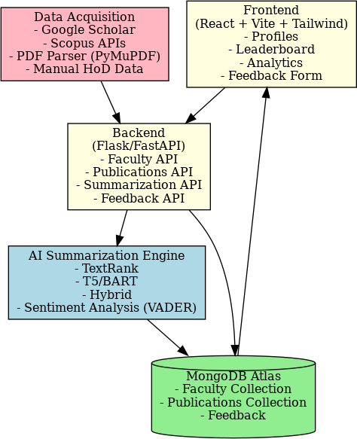

Fig. 1. System Architecture

PDF parsing with PyMuPDF for abstracts
Schema design for Faculty Publications in MongoDB
  - Frontend Ranking (Tousif)
React + Vite + TailwindCSS frontend
Faculty list, profile, and ranking leaderboard pages Ranking algorithm based on publications, citations, and teaching weights
Charts/graphs for analytics (Recharts/Chart.js)
  - Feedback Analysis UI Enhancements (Abid) Feedback collection form + API
Sentiment analysis with VADER/TextBlob
Simple About Landing pages Integration testing docu- mentation
- Flow of System
  - Faculty data is collected (via HoD or external APIs).
  - Publications are added to the system via /add-publication or batch APIs.
  - Summaries are auto-generated (extractive + abstractive + hybrid).
  - Summarized data is stored in MongoDB and made avail- able through APIs.
  - Frontend fetches data and displays profiles, rankings, and analytics.
  - Students provide feedback, which is stored and analyzed for sentiment.
  - Final integrated system provides faculty analytics + sum- marized research visibility.
- Expected results
  - Automatic summaries of faculty publications (both short and detailed).

Fig. 2. Flowchart

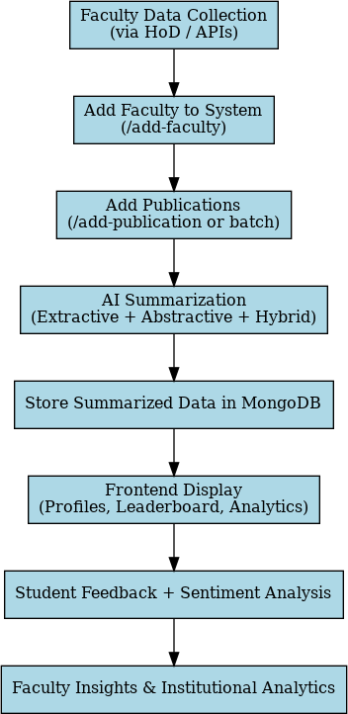
- Institution-wide faculty leaderboard ranking by research output.
- Faculty profiles that are easily accessible to students, staff, and management.
- Student feedback with sentiment insights.
- Charts showing publication trends and departmental an- alytics.

- ADVANTAGES OF PROPOSED SYSTEM
- Saves faculty/admin time by automating profile and pub- lication updates.
- Enhances research visibility for the institution.
- Helps students quickly understand complex faculty pub- lications.
- Provides institutional insights for decision-making and rankings.

  - Scalable and deployable on cloud (Render/Railway + MongoDB Atlas).
- Conclusion
AcademiQ provides an innovative approach to faculty an- alytics and publication management by combining AI-based summarization, feedback analysis, and institutional dash- boards. This project aligns with the growing need for automa- tion in academic institutions and provides a foundation for future enhancements such as cross-institutional comparison, plagiarism detection, and advanced AI-based recommenda- tions.
Acknowledgment
I would like to express my sincere appreciation to all those who have supported and guided me during this research work. I begin by extending my deepest gratitude to my research advisor, Prof. Supriya Shrivastav, for her dedicated guidance, encouragement, and valuable suggestions, which have been central to the successful completion of this study. Her men- torship not only helped me refine my ideas but also gave me
the confidence to overcome challenges along the way.
I would also like to express my appreciation to the fac- ulty members, staff, and administration of AMC Engineering College and the Department of Computer Science and Engi- neering for providing the academic environment, facilities, and resources required to complete this research.
In addition, I acknowledge the valuable contributions of my teammates — Mohammed Zahid, Mohammed Tousif, Hari Krishna Yadav, and Syed Abid — whose collaborative efforts, ideas, and dedication were instrumental in the successful development of this project.
Finally, I am profoundly grateful to my family and friends for their constant encouragement, patience, and moral support, which were essential in the successful completion of this work. The completion of this research has been made possible through the collective guidance, encouragement, and contri-
butions of all the individuals acknowledged above.
References
- Yang, D., Zhang, A. N. (2017). Performing literature review using text mining, Part III: Summarizing articles using TextRank. Singapore Institute of Manufacturing Technology (SIMTech).
- Gupta, R., Singh, A. (2017). ”Towards a Unified Faculty Information System: Challenges and Opportunities.” Proceedings of the International Conference on Academic Management Systems, pp. 112-120.
- Davies, J., Patel, S. (2020). ”Beyond Citations: A Multi-Dimensional Framework for Assessing Academic Impact.” Journal of Scholarly Metrics and Evaluation, 7(1), 25-40.
- Li, J., Zhang, W. (2016). ”A Hybrid Approach to Ranking Researchers Based on Publication Impact and Collaboration Networks.” IEEE Trans- actions on Knowledge and Data Engineering, 28(9), 2450-2462.
- Kim, S., Lee, H. (2018). ”Seamless Integration of Digital Portfolios in University Ecosystems: Challenges and Best Practices.” Higher Educa- tion Technology Journal, 5(2), 78-92.
- Legal Text Summarizer. (2023). In 2023 14th International Conference on Computing Communication and Networking Technologies (ICCCNT)
- Meeting Summarizer using Natural Language Processing. (2022). In 2022 6th International Conference on Trends in Electronics and Infor- matics (ICOEI)
- A Novel Framework for Semantic Oriented Abstractive Text Summa- rization. (2018). Journal of Web Engineering, 17(8), 1-15.
- A Novel Approach to Text Summarization of Document. (2023). In 2023 Third International Conference on Advances in Electrical, Computing, Communication and Sustainable Technologies (ICAECT) (pp. 1-6). IEEE.
- Palliyali, A. W., Al-Khalifa, M. A., Farooq, S., Abinahed, J., Al-Ansari, A., Jaoua, A. (2021). Comparative Study of Extractive Text Summa- rization Techniques. In 2021 IEEE/ACS 18th International Conference on Computer Systems and Applications (AICCSA)
- Chen, L., Wang, Y. (2019). ”Automated Abstract Generation for Scientific Literature using Hybrid Models.” Journal of Natural Language Processing Applications, 12(3), 45-58.
- Mihalcea, R., Tarau, P. (2004).”TextRank: Bringing Order into Texts.” Proceedings of EMNLP 2004.
- See, A., Liu, P. J., Manning, C. D. (2017).”Get to the Point: Summa- rization with Pointer- Generator Networks.” Proceedings of ACL 2017.
- Tang, J., Zhang, J., Yao, L., Li, J., Zhang, L., Su, Z. (2008).”ArnetMiner: Extraction and Mining of Academic Social Networks.” Proceedings of KDD 2008.
- Teufel, S., Moens, M. (2002).”Summarizing Scientific Articles: Exper- iments with Relevance and Rhetorical Status.” Computational Linguis- tics, 28(4), 409–445.

